National Donor Sabbath Bulletin Announcements
Give Thanks. Give Life. November 14-16, 2014 is National Donor Sabbath Weekend.
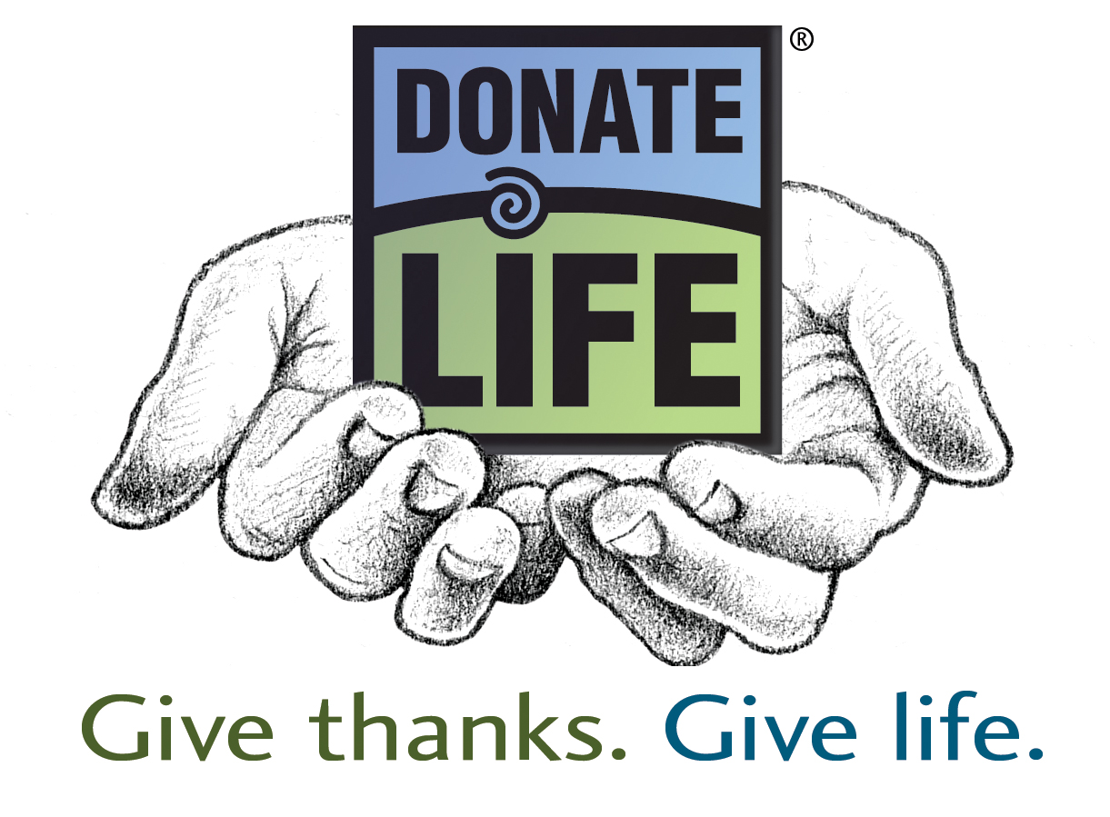
Thousands of Americans are in need of vital organs, eyes and tissues.
For many, the chance to live a full life won’t come unless more of us consider organ, eye and tissue donation.
Each one of us has the potential to save up to eight lives as an organ donor and touch another fifty as a tissue donor.
To think of others in a time of grief and sorrow is truly compassionate and selfless.
Please consider the gift of life: organ, eye and tissue donation.
After services, discuss organ, eye and tissue donation with your family and friends. Let them know that you understand the critical need for donors. Eighteen people die every day waiting for an organ transplant. Remind them that there is no cost for giving the gift of life. All you need to do is say YES.
Our congregation supports donation in the spirit of love and generosity.
Our congregation supports organ, eye and tissue donation as the gift of life and the expression of our highest humanitarian ideals. We ask that all members of the congregation consider becoming organ, eye and tissue donors.
Our congregation supports and encourages donation as the ultimate gift from one person to another. Give the Gift of Life - please consider enrolling in the donor registry.
------------------
TO ENROLL IN THE NEW YORK STATE DONATE LIFE REGISTRY,
and to find out more about organ donation, visit the website of
Finger Lakes Donor Recovery Network:
www.DonorRecovery.org

